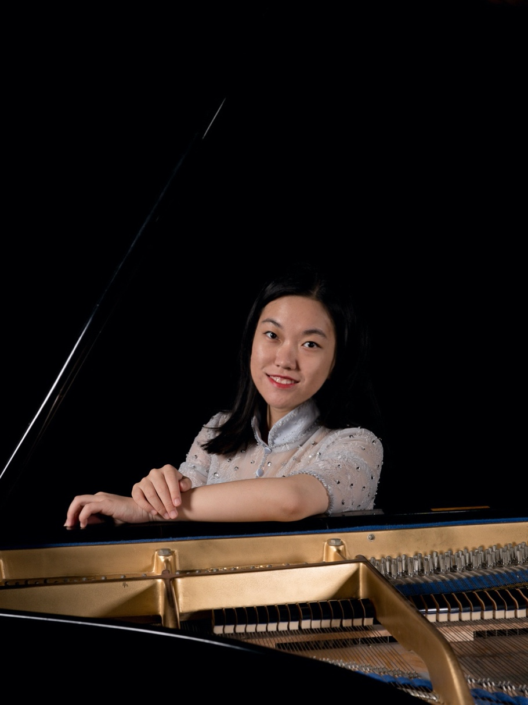

Biography

Anran Qian is an adventurous musician who not only loves performing on the stage, but also enjoys connecting with different people whether it is through performing classical music, improvising, composing, or teaching. Being passionate about arts, Qian strives to bring people together and foster connections between art and everyday life.

Born into a musical family, Anran Qian started playing the piano at the age of four under the guidance of her parents. As a child, she spent many hours scribbling stories and realized that she loved telling stories on a piano keyboard even more than with a pencil. Selected amongst thousands of applicants to the Middle School Affiliated with Wuhan Conservatory in China, she received professional music training from the age of twelve. Possessing an adventurous spirit even at this young age, she left home after being invited to attend the Middle School Affiliated with Shanghai Conservatory and later entered The Juilliard School in the United States. She has performed in Beijing, Shanghai, Wuhan, Suzhou, and Guangzhou in China, Kirishima in Japan, New York City and Seattle in America, and Bergen in the Netherlands. She is currently pursuing her Doctor of Musical Arts degree at Boston University under the guidance of Tanya Gabrielian.

As a young pianist, Anran was a prizewinner in many competitions including Omille Piano Competition in China, Cooper Piano Festival Competition in the United States, and Beijing International Music Festival and Academy Concerto Competition. Her career has brought her to perform and take masterclasses with many renowned musicians including Vladimir Feltsman, Pavel Gililov, Minoru Nojima, and Boris Slutsky. She has participated in music festivals around the world such as the Beijing International Music Festival and Academy in China, Kirishima International Music Festival in Japan, Art of the Piano in America, and The International Holland Music Sessions in the Netherlands.

Anran Qian began teaching at the age of ten, assisting her father, pianist Guorong Qian, serving as his private teaching assistant. During the past ten years, her private students have been accepted at conservatories such as Wuhan Conservatory of Music, Cleveland Institute of Music, Conservatoire de Grenoble, and many others. Anran Qian has also been selected as a Teaching Fellow at The Juilliard School, where she instructed professional musicians with piano skills, ear training, and music theory. Invited to be a piano instructor at Two Bridges Music in New York, Anran Qian is also experienced in teaching young students at various levels.
Besides music, Anran Qian also enjoys other different forms of art, such as movies, books, dance performances, and galleries. She finds inspirations in all forms of art and is always eager to learn more about them, for she believes that every art form connects with each other. Anran Qian is also highly interested in inter-disciplinary projects. Recently she has performed with dancer Can Wang at The Juilliard School on a piano solo piece “Duo Ye” by composer Chen Yi; and also worked with actor Phillip Stoddard in PianoScope at The Juilliard School on Copland’s Three Moods. Recently, Anran has been asked to be the Music Editor for the Chamber Music Society of the United Nations, where she is responsible for the final recording of each performance.

Chopin Etude Op. 10 No. 8

Anran’s Composition: Prayer for Wuhan, 2020

Links to Anran’s Social Media:

Instagram
YouTube
SoundCloud

